Learning Opportunities - Grade 6 / 7 / 8

Cultural Activities

Topic - Elders
Elders are very important people in our First Nation culture. They are the people who carry great wisdom, teachings, stories, traditions and most importantly our languages. Many of us have elders in our lives who we look up to. We seek their advice and opinions when we are unsure of things. In today’s times we are often seeking out our elders for their language and stories of when they were young.

Activity

Task #1
- Identify an elder in your life who is very important to you.
- If you have more than one elder that is important in your life that is great! Feel free to share more than one.
- Find a picture of the elder you have chosen. This picture could an individual picture or a picture of you with them.
- Ask permission of the elder to share their photo for this assignment.
Task #2

- Once you have chosen your elder share why this elder is so important to you.
- Have the taught you any of the following:
- Shared a story
- Shared a traditional teaching
- Shared their wisdom
- Gave you advice
- Taught you your language
- You may complete this by writing down your teachings on a piece of paper or complete it on an electronic device.
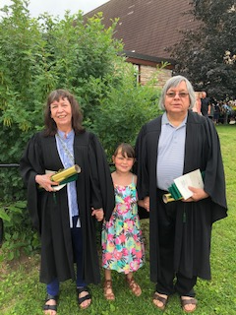
My Meme & Momo are two very important elders in my life. They are the reason why I have so much knowledge to teach my students. They have taught me that with hard work and determination anything can be accomplished!

If you would like to show off your artwork you may email it to me at Molly.Brown@nbed.nb.ca
Woliwon, Miss Topkwancihte

